J.R.R Tolkien once told an allegory about a man who used stones from the ruins of an ancient hall to build a tower. Soon his friends came along and went to work investigating the stones of the tower. To get a better understanding of the stones and their value they knocked the tower over. This led to deeper digging and further speculation about the nature of the structure. Eventually they all began to wonder why the odd, old man had built such a "nonsensical" tower. What they failed to realize was that from the top of the tower, which was now in shambles, he had a beautiful view of the sea.

Tolkien, of course, is poking fun at the way most professional literary critics and scholars tend to approach stories, especially old ones. They come with their picks and shovels to dismantle the story without ever stopping to actually enjoy it. Perhaps, authors write stories to, of all things, be enjoyed.

That is the attitude that we want to approach our summer reading challenge with. Sure, there are prizes, but the heart of it is to cultivate the love, the taste, for reading good books. During the school year we read, narrate, and discuss some truly wonderful stories. Over the summer we encourage you to read widely, and read deeply, but do it for no other reason than the enjoyment of reading good writing. Just like developing a taste for fine wine or good barbeque requires years of sampling excellent examples, so developing a taste for good books takes the intentional act of reading excellent stories.

In the "Parent Portal 2025-26" folder on Google Drive you will find a folder titled "Summer Reading." In it you will find reading lists for each grade level and a Bingo sheet for each grade level. All you need to do is print off the appropriate Bingo/Reading Tracker sheet for your student(s) and start reading. We are indebted to Providence Classical School for the information and reading lists presented here. There are three levels of the challenge: traditional Bingo, perimeter Bingo, and blackout Bingo. Each level comes with its own set of prizes.

Incoming First and Second Grade Students: New this year - rather than completing a certain number of books, we want to set reading goals based on the number of minutes you read! We want you to try and read for 20 minutes each day. You can do this all at once or spread it over the day. If you read 20 minutes M-F over the summer you will have read for 1,000 minutes! Your award levels (Black Out, Perimeter & Prize Store) will be based on how many minutes you read.

Upper Schoolers should use the 6th Grade BINGO sheet OR “The Literary Life Kids’ Reading Challenge” and can select their books from the Incoming Sixth Grade reading list OR the Ambrose Summer Reading list (Grade level of 6 and above).

Reading Lists

The reading lists are based on appropriateness of content, level of challenge, and overall fit with each grade level. All books listed are the unabridged editions.

Next week we will finish sharing our Parent Previews for each grade which will include their literature selections. Because these books are scheduled to be read next school year, students should not read these titles for the Summer Challenge. This will avoid frustrations for both student and teacher when those books are read in class. Parents, however, are strongly encouraged to read from this list to better familiarize themselves with the books their children will be reading throughout the school year.

Prizes (3rd & Up):

Traditional Bingo: Select a prize from a prize table (up to 4 prizes
Perimeter Bingo: Pizza & Ice Cream party at school.
Blackout Bingo: Stars & Strikes Bowling trip

Prizes (1st & 2nd Grade):

Prize Store: Select a prize for every 100 minutes you read (up to 4 prizes)
Perimeter Bingo (400 minutes): Pizza & Ice Cream party at school.
Blackout Bingo (800 minutes): Stars & Stripes Bowling trip

Potential Questions or Points of Confusion:

What am I supposed to do? How does this work?
Enjoy reading books! Read lots of them! Select a book you haven’t read before from your grade’s booklist (or higher). Read it. When you have finished, write it on your Bingo card in the appropriate square. Then read another book! You might want to plan ahead and choose your next book and the next in such a way that you will soon be able to make a Bingo on your Bingo card.

How do I keep track of what books I have read?
This is easy! You MUST write the title and author of the book in the bingo square it matches. An “X” or sticker in a bingo square will not be counted as a book read. Here is an example of how a square should be filled out:
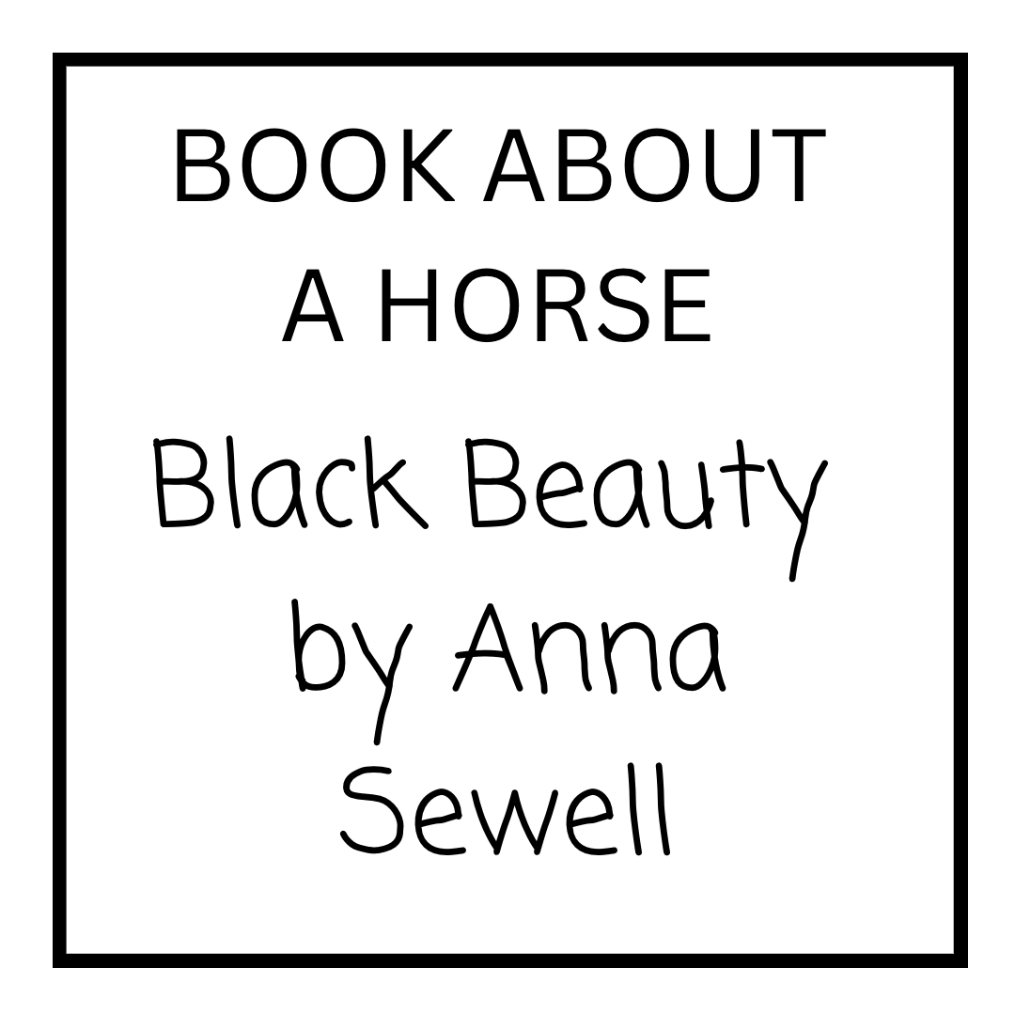
Black Beauty is a book about a horse. It’s also fiction. Can I write it down in both squares then?
No. Books only count for one square each. Read a new book for each square.

How do I earn prizes?
There are 3 ways to earn prizes.
Level 1 Prize: Classic Bingo (any direction, up to 3 prizes)
Level 2 Prize: Perimeter Bingo
Level 3 prize: Blackout Bingo

I’m looking at my Bingo sheet and see FREE SPACE (ANY BOOK). What does that mean?
Free spaces may be filled with any book you like, as long as it is at your grade level (compare it to others on the booklist or ask your mom or dad what they think.) If you are entering grade 2-6, the book also needs to be at least 100 pages long.

There’s a book on my classes booklist I’ve read before, but I really love it and want to read again. Can I read it again for Bingo?
Do you know that little song that starts, “Make new friends, but keep the old...”? It is wonderful to keep the old friend of a familiar book. But in Summer Bingo, please make a new friend and read a new book. No rereading old books for Summer Bingo, unless it is specifically listed on your sheet (Upper School Literary Life has a re-read space).

May I read from a different grade’s booklist? Their books look pretty good too.
There are many books on your own list to pick from. You shouldn’t run out. But if you like, you may read a book from the list one grade level up from your own to fill one of your “Challenge” squares. And of course, for “Free Spaces”, you may choose your own reading level appropriate book, from another grade’s book list or just from your own bookshelf.

I can’t find a book on my list that I haven’t read and fits a category I need.
Follow the “Free Space” guidelines above.

How much time do I have to work on this? How do I claim my prize?
You have the whole summer to read! Hooray! Return your completed Bingo sheet (book titles and authors listed in the squares, signed at the bottom by you and a parent) to your teacher during the first week of school. Prizes will be awarded in September.

Does listening to an audiobook count?
In moderation. Audiobooks are great and we love utilizing them, but for the Summer Reading Challenge one of our goals is to build reading skills. We encourage you to read aloud to a parent or sibling if it helps you! BUT, we know you are likely to spend lots of time in the car & what better way to pass the time than to listen to an audiobook! Or maybe you have daily house chores and an audiobook would help pass the time. Great news! This year you may count up to 5 audiobooks for the reading challenge!! They still must fit into the category and you should mark the square with an *asterisk*.

My child is a struggling reader. Can I read the book to them?
No. The goal of this challenge is to help them practice their reading skills, so we encourage you to sit with them while they read aloud to you and assist as needed. We understand that not every student reads at the same fluency as their “grade level” may indicate. Each list has many titles to choose from and we encourage you to help your student make selections appropriate to their ability.

A final note. This is meant to be a challenge! Celebrate each book your child reads and encourage them to read another…and another. Each book read is a victory, whether a prize is earned or not. The challenge is designed so that everyone will hopefully win something. But it is also designed to make Bingo Blackout an extra special accomplishment for those who set a lofty reading goal for themselves.

Let us know if you have any questions or if we have “muddied the water”!

Happy reading!
Christian & Andrea

